Warmup Activity

Sanghyuk Lee(129405171)

Script File:

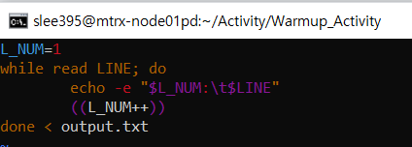

L_NUM is the variable initialized by number 1.

It starts to read the line by using while loop.

It shows the line number starting 1 and the content of the file.

Increase the variable L_NUM so that on the next line, it will show the increased index on the left side.

It ends up looping with reading the content of the file output.txt.

Content of Output file

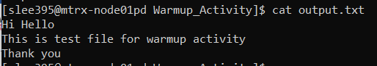

Output:

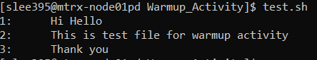

Changed code

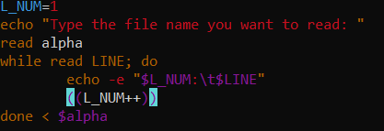

Output:

